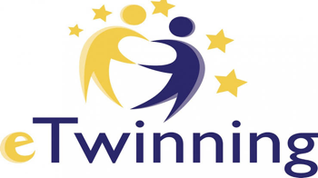

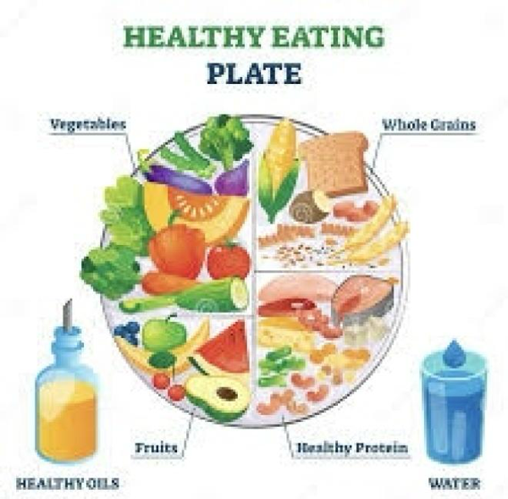
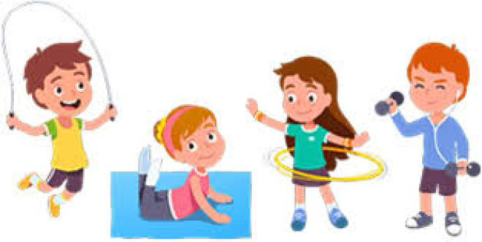
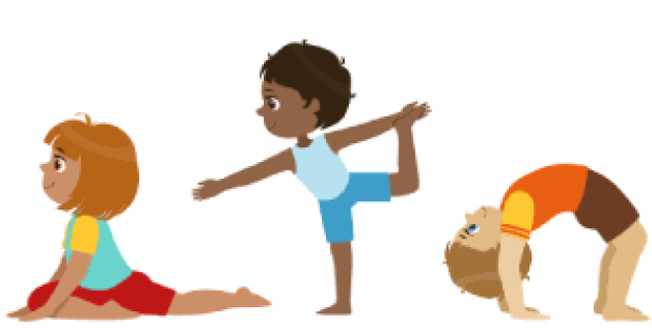
Eat Healthily, Move And Live Happily





eTwinning project called “Eat Healthily, Move, And Live Happily” was carried out by the cofounder, English teacher at Cengiz Topel Secondary School, Tuğba BOZKURT and the cofounder Cristina Maria Hangea from Romania. Ten teachers and fourtyeight students from countries such as Turkey, Romania, Georgia and Italy participated in this project. The aim of this project is to raise awareness of allergenic foods and Type 1 and Type 2 diabetes. balanced nutrition and healthy living among secondary school students to consider in nutrition, food groups, choosing the right food,active life to guide them on nutrition, and to give them the habit of physical activity through fun activities and games.In order to instill the awareness of consuming healthy products, we encourage the secondary school students to plant seasonal products such as cress, parsley, arugula, dill, etc. in school hobby gardens or vineyards, to consume these products in their salads. Thus, they have fun by taking photos and videos.In order to raise awareness among students about reading and interpreting the contents of packaged foods, they will be asked to bring products they consume frequently, and after that they will examine the nutritional labels on the back, analyze them and present them with posters, that is, they will take on the role of food detectives. Meanwhile, they will develop their narrative skills, cooperation and
Turkey Romania Italy Georgia
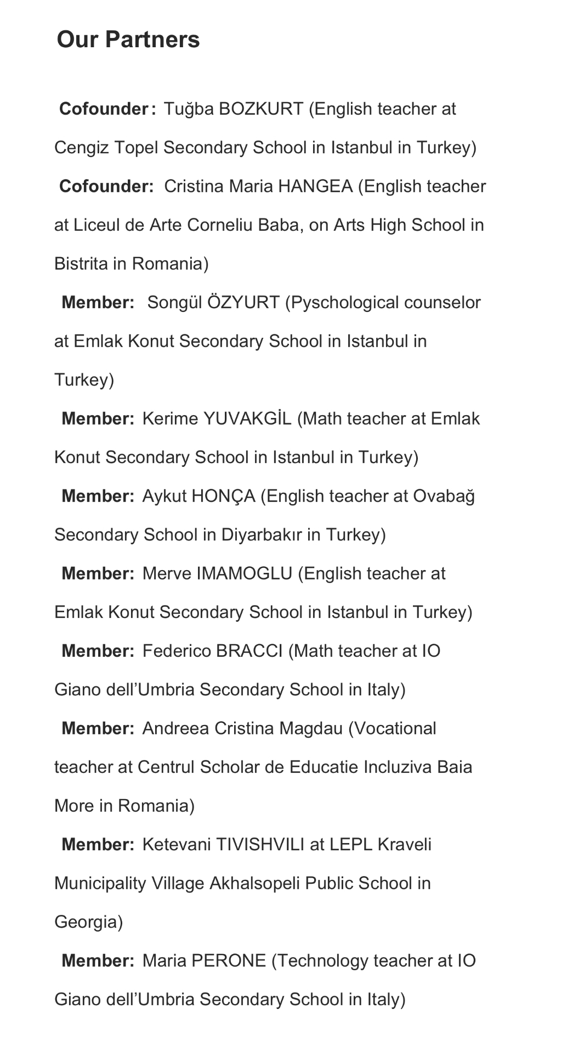
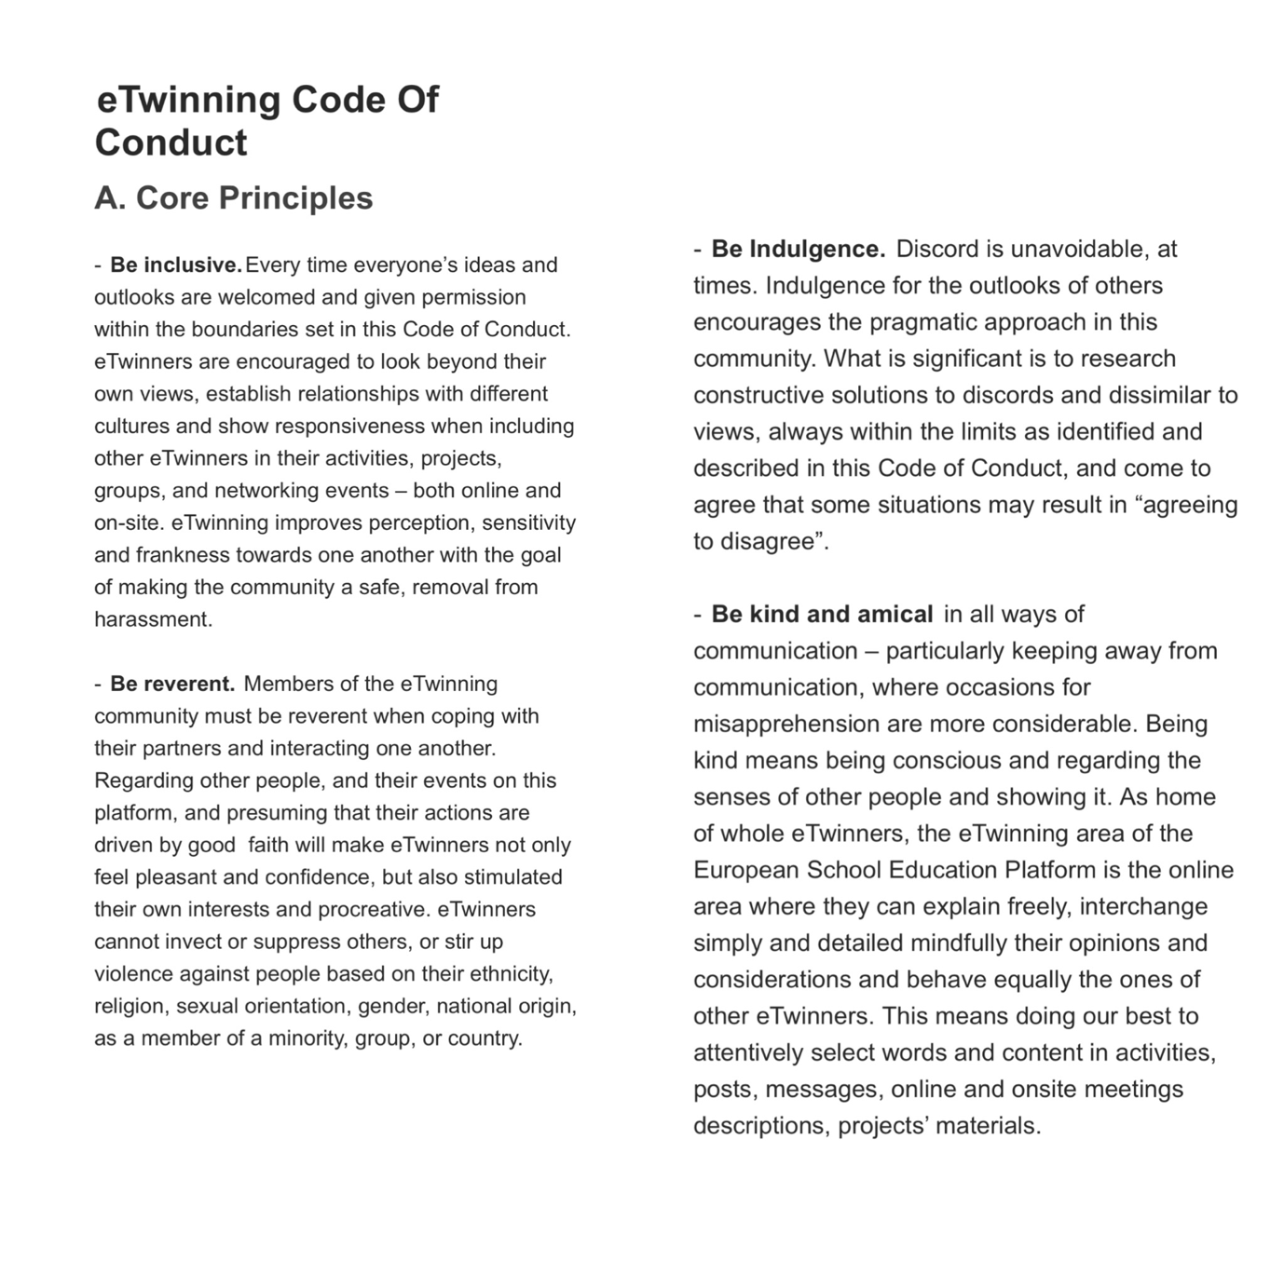

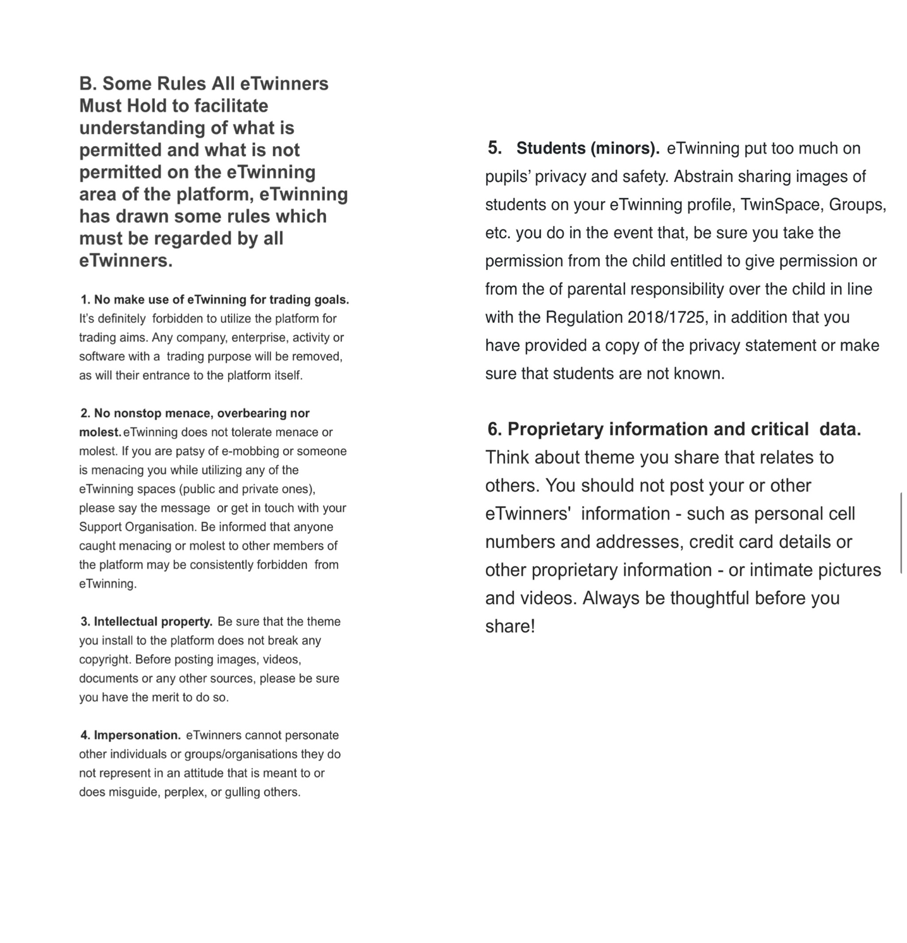

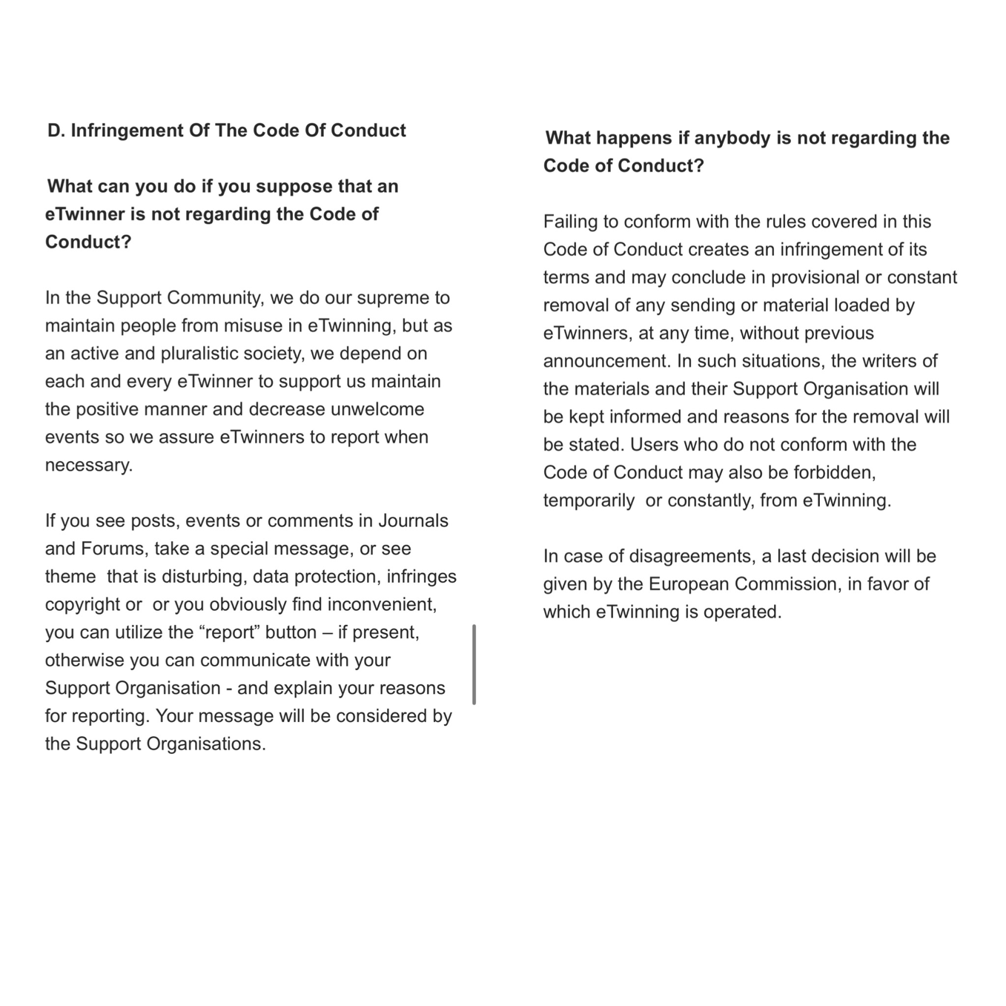
esafety
We pay attention to data protection and copyright in our e-Twinning project. We open an e-safety page on pages section on Twinspace. We wrote the rules there. All the members of the project have learned all the rules of e-safety from this page. Thus, we raise awareness about e-safety for our project. As soon as our project starts, we take parent permissions from the parents and put them on the pages hiding the students’ and the parents’ private information. We give importance to not to share personal information of our pupils, too.
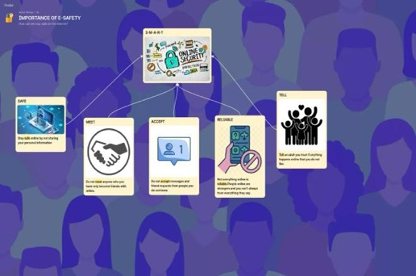
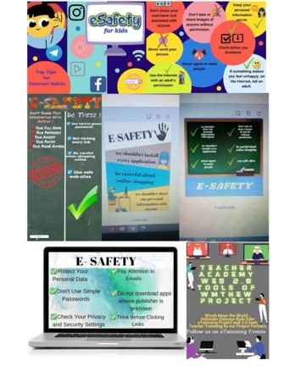
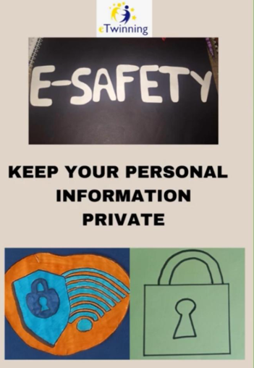
https://padlet.com/aykuthoncaa/importance-of-e-safety-o15q4wafnk392sol

Parent Permission Slips
We took parent permission slips from parents of the students to participate in this project before starting the project. We kept their personal information private.

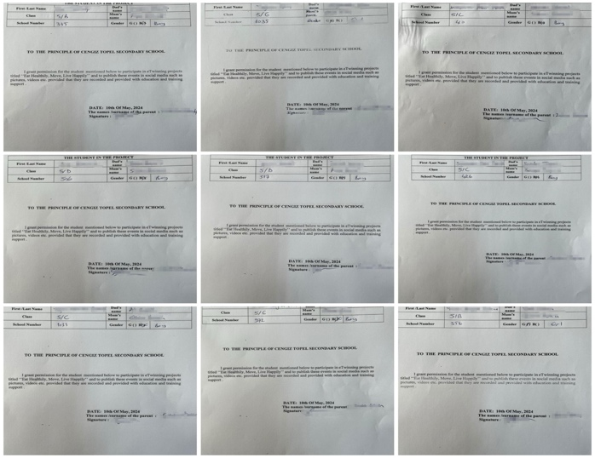
Parent Permission Slips
Images of students were hidden during the activities carried out in the projects. We hide their faces blurring or using emoji in the photos or videos we add on Twinspace.

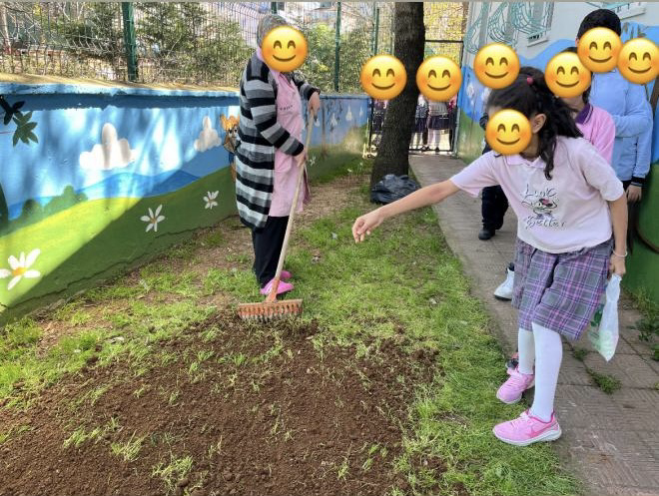

Our project includes activities such as E-safety. Students played Kahoot.
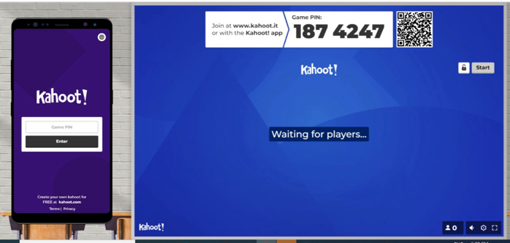

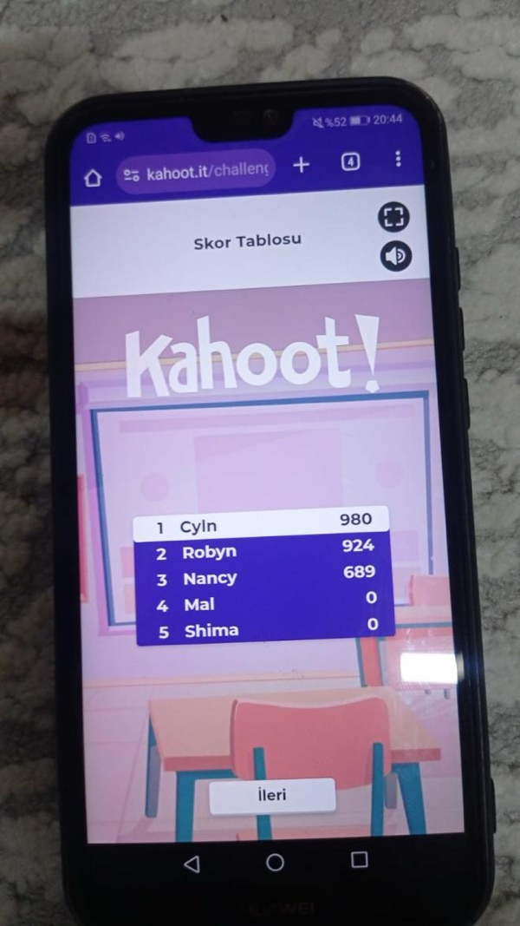
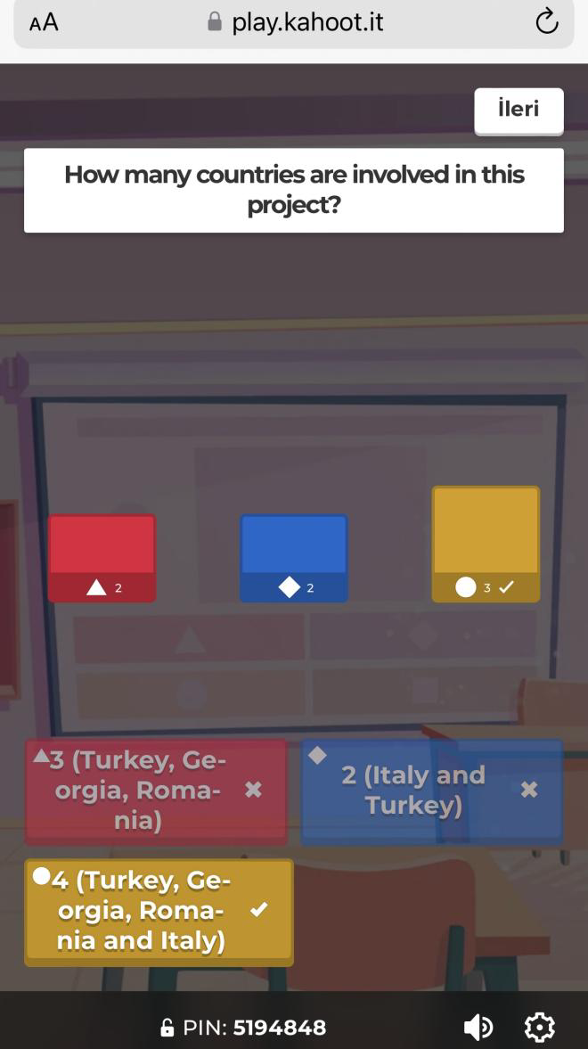
We prepared a poster from Canva to announce our meeting
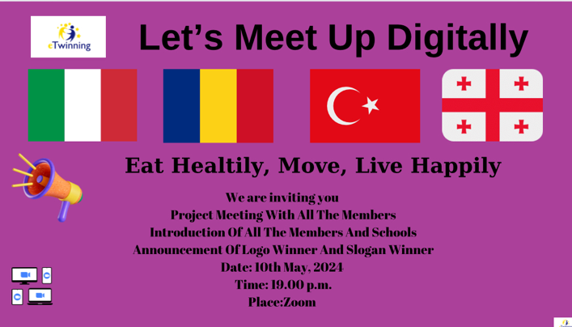
We held our first online meeting via Zoom to introduce all the members, the project description, purposes, contents of the project, esafety rules, web 2 tools, work process of the project, the activities we made.

The Teachers And The Students Online Meeting

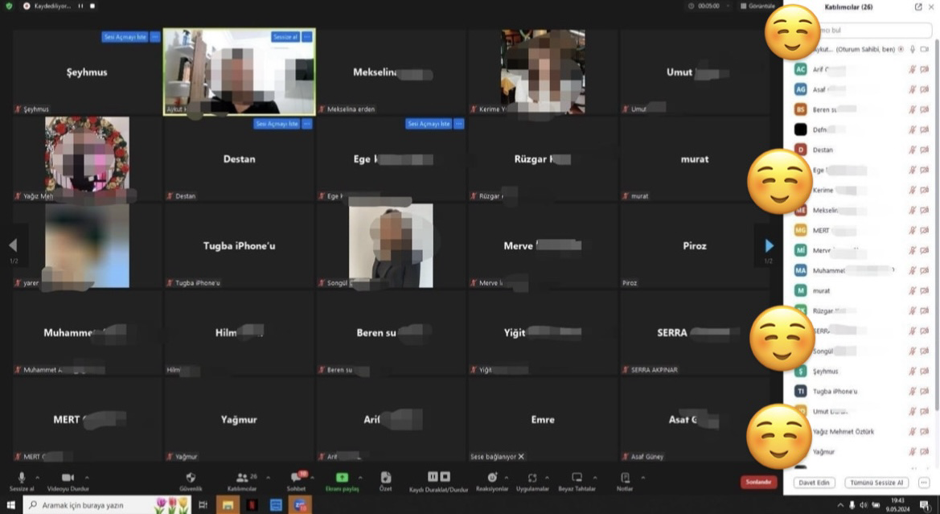

Web 2 Technology and Web 2 Tools



What is web 2 technology? What are the contributions of the use of Web 2 technology to the educational environment?

Web 2 technology allows users to provide information, share, discuss from the receiving location, produce information, etc. are the internet environments in which the user is active. It creates a more active and participatory classroom environment. It improves positive attitudes of students in the educational environment towards each other. It contributes to the development of skills such as group work, effective learning, high level thinking, constructivist learning, individual learning, and taking responsibility in educational environment.

Web 2 Applications We Will Use In Education

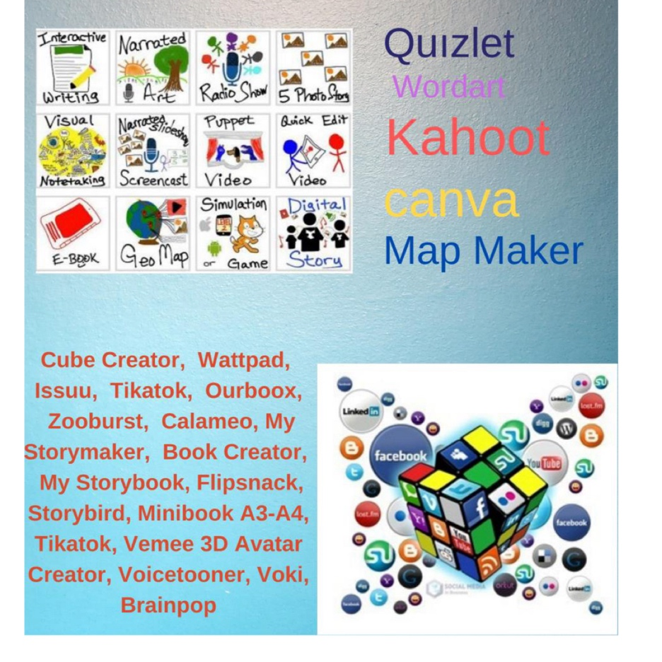

Students Create The Project Logo And The Project Slogan Via Canva
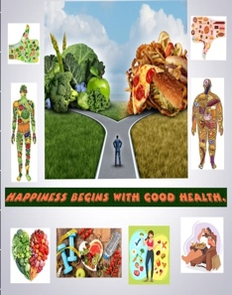
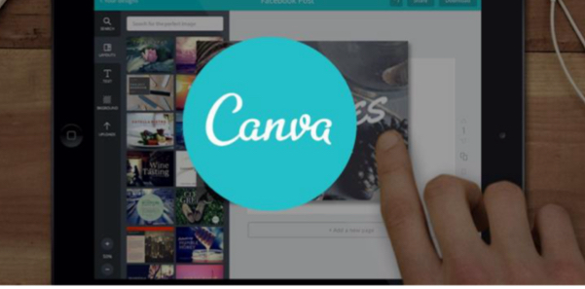
We created our logo and posters together with our partners to represent our project. Students create the project logo and the project slogan via Canva. As a result of the poll of the project logo, the project slogan, these logo and slogan were chosen as the best by the all the students.
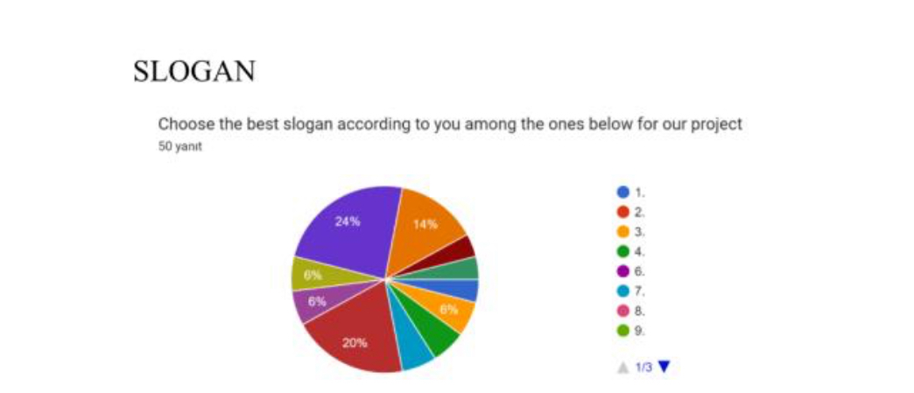
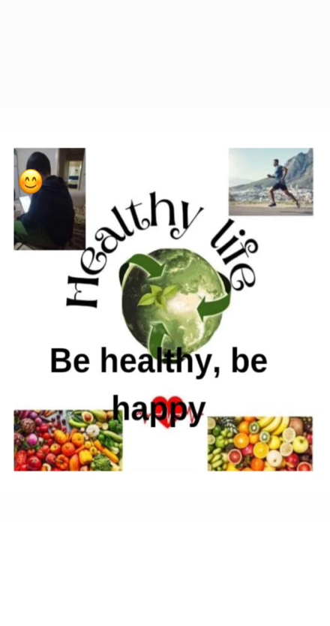
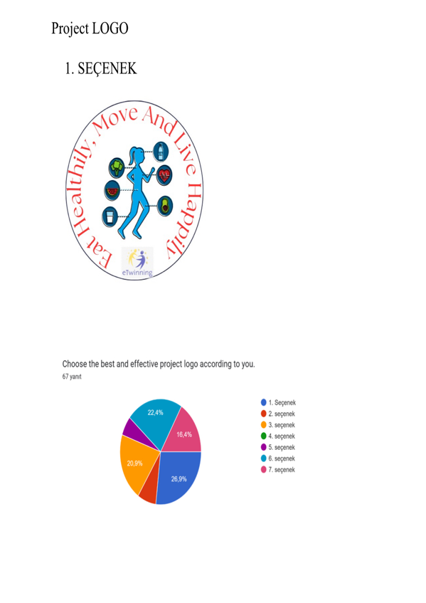
Students chose the best and the most effective project logo and the project slogan.

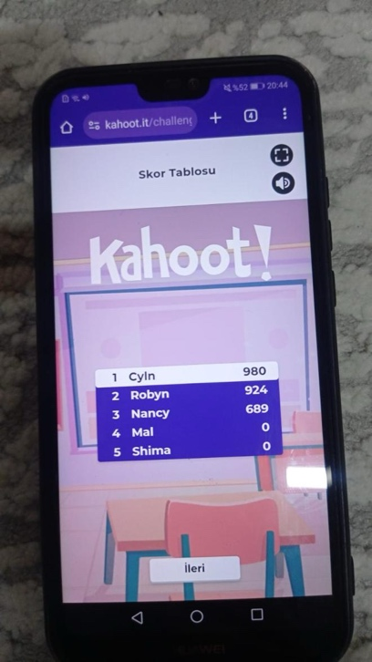
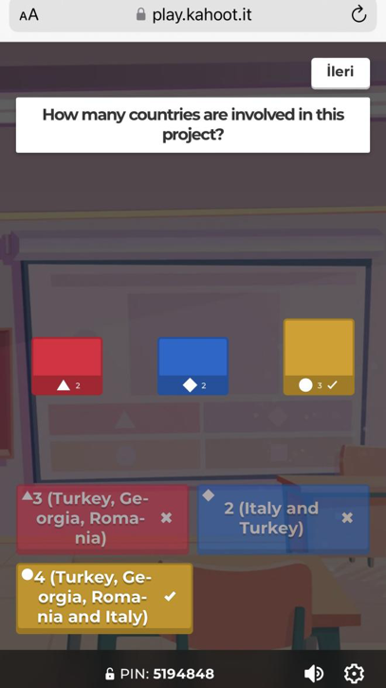
Students. played Kahoot to evaluate activities in May and in June.

Google forms were used to create “Eating Healthily, Move And Live Happily” project pre-survey and post-survey forms for students, teachers, and parents. These links are below to click on them to see.

https://docs.google.com/forms/d/e/1FAIpQLSe44F-u8Oy0ePHZTQV4krv0CgMQ5viGpTi3B4WfB3F4TKBYaQ/viewform

https://docs.google.com/forms/d/1UmlHyXMulvLIDV_Syd7pYhuoL57fNxQePy4Z1oxT3uk/edit

https://docs.google.com/forms/u/0/d/e/1FAIpQLScLMV0WYJiM0XTWX5RZesRxNhhmt7HGXWU1tPuIeh9kW84DKA/formResponse

https://docs.google.com/forms/d/1TYpHnjVhrD7_QbEK03W7sQs0XSiz7NyVbJjxQ_Na-TA/edit

Students introduced themselves via Chatterpix and ToonApp and they improved English speaking skills.

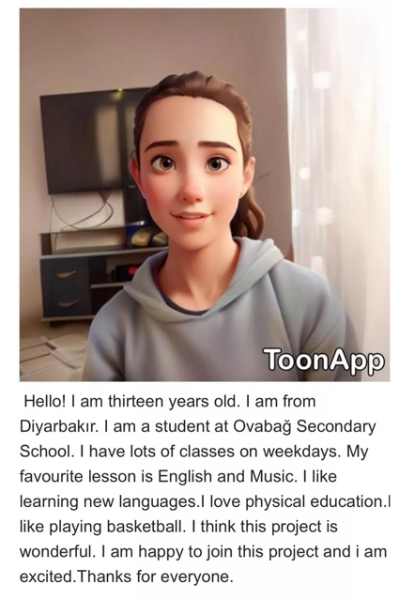
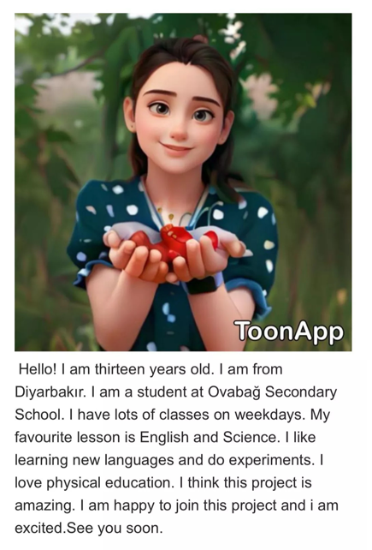
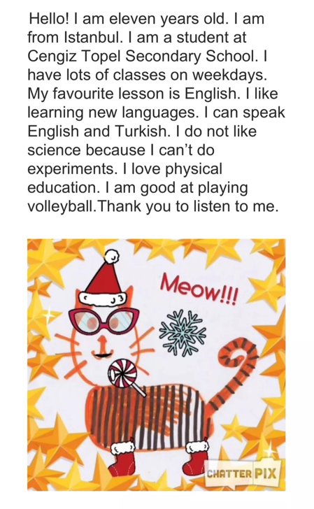
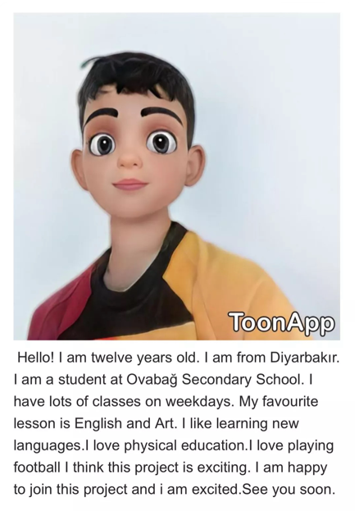
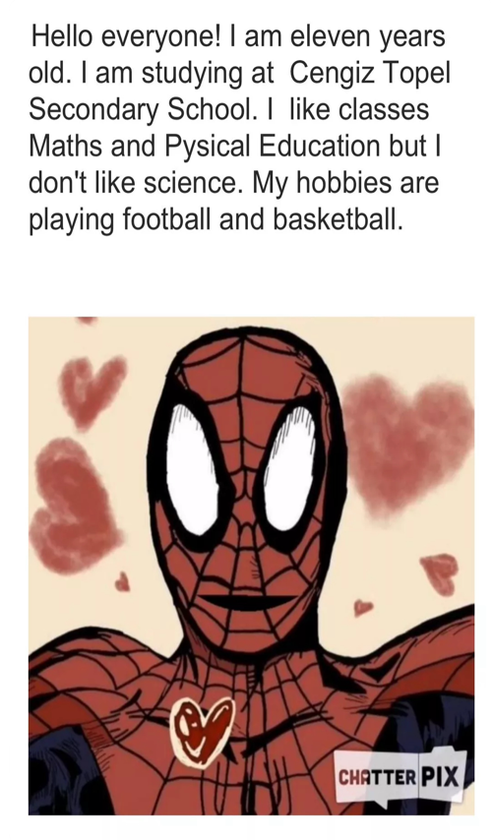

Meeting With The Dietician, The Teachers And The Students on Zoom

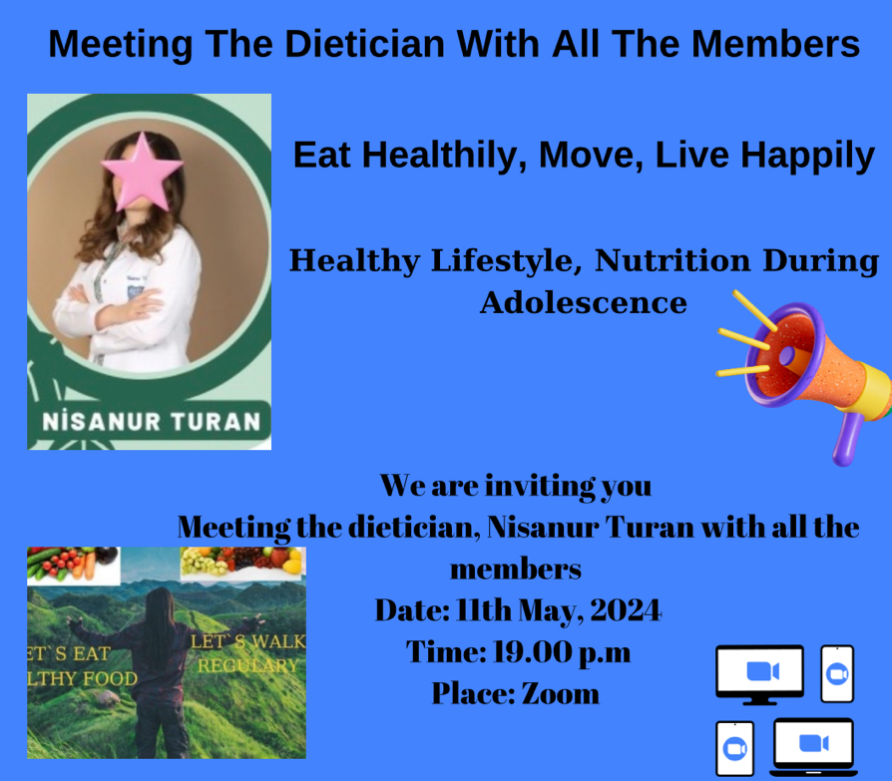

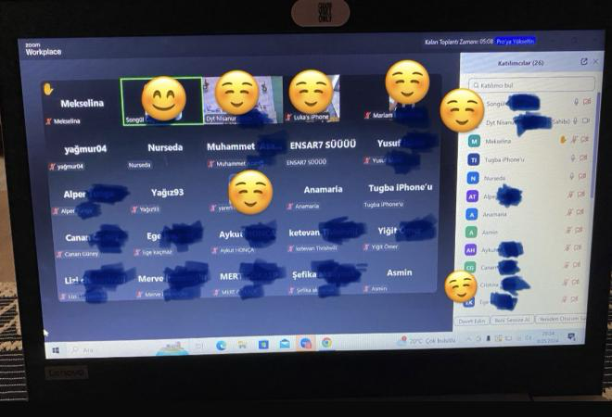

The Dietician explained benefits of balanced nutrition, food groups, vitamins, proteins, and physical activities. The students asked her questions of the balanced nutrition.

The students planted seasonal products to eat healthily.

Students prepared brochures of daily menu via Canva.

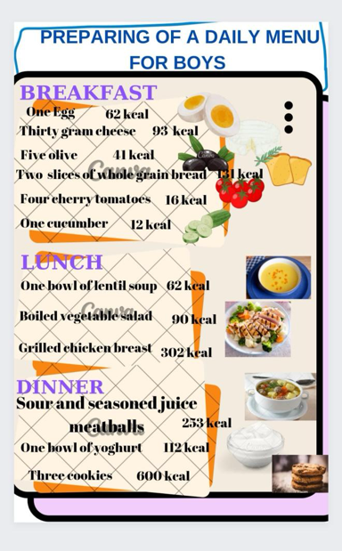
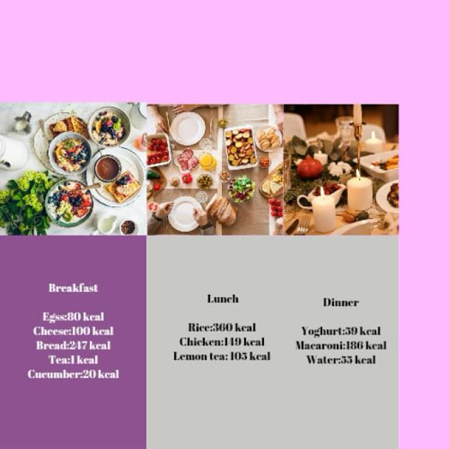
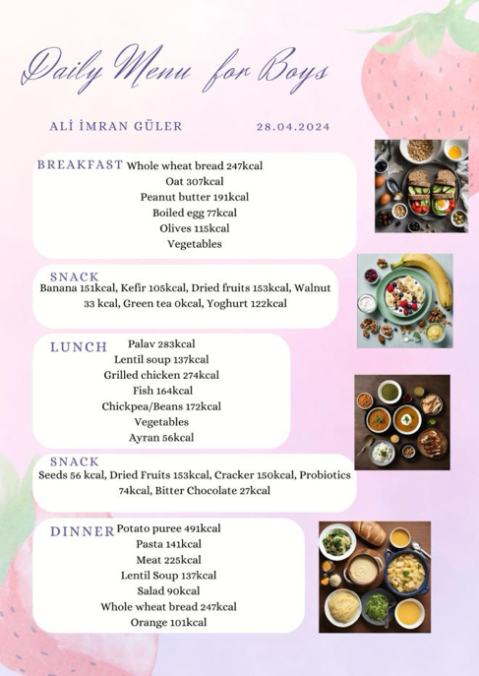

Skipping A Rope Competition At Ovabağ Secondary School
Skipping a rope competition was organized at Ovabağ Secondary School. It is thought to encourage the students skipping a rope in case of benefits of their health. They competed fiercely in fun competition. One of the girl students became winner of the skipping rope competition and was given a gift. While skipping a rope, they had fun time and an enjoyable activity.

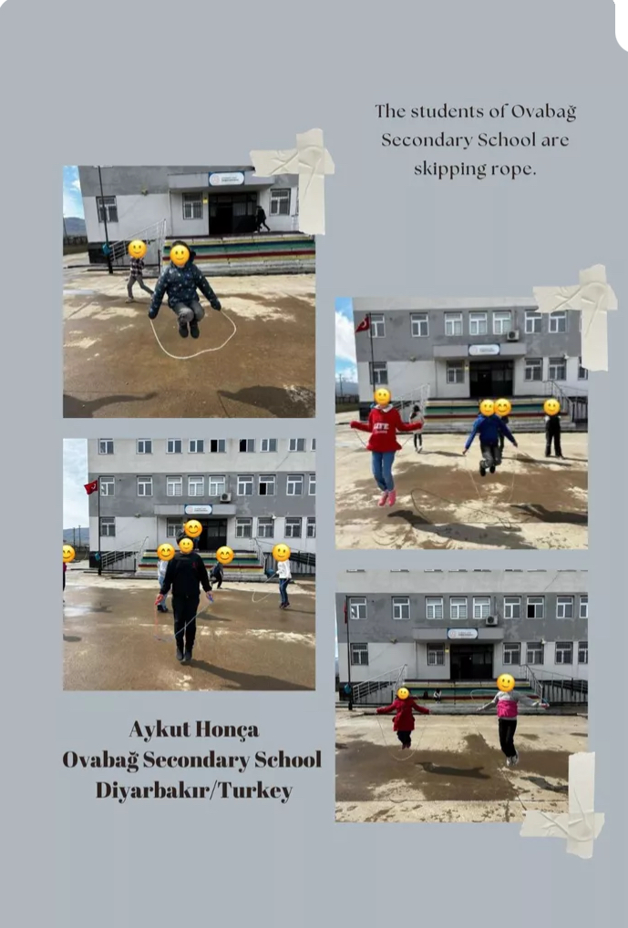

A Food Pyramid Game Competition At Ovabağ Secondary School

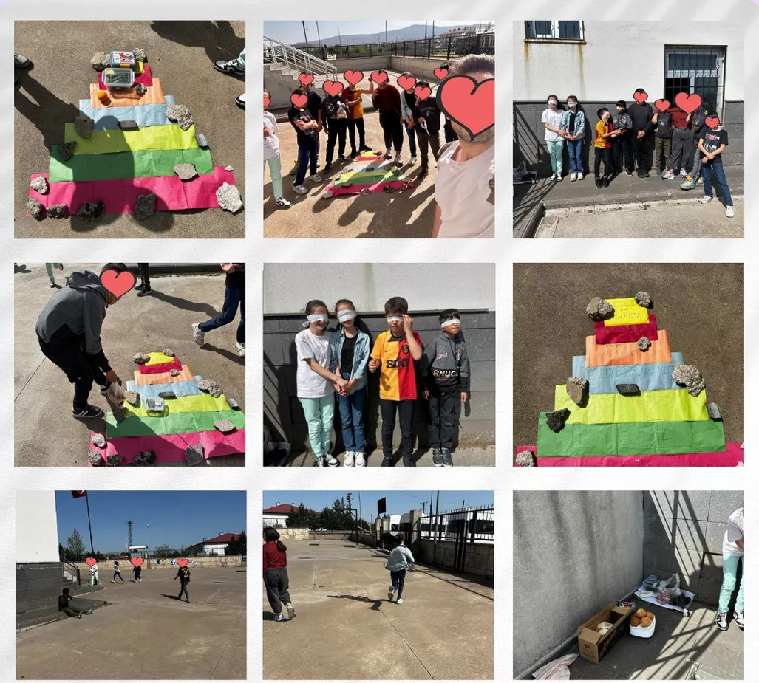

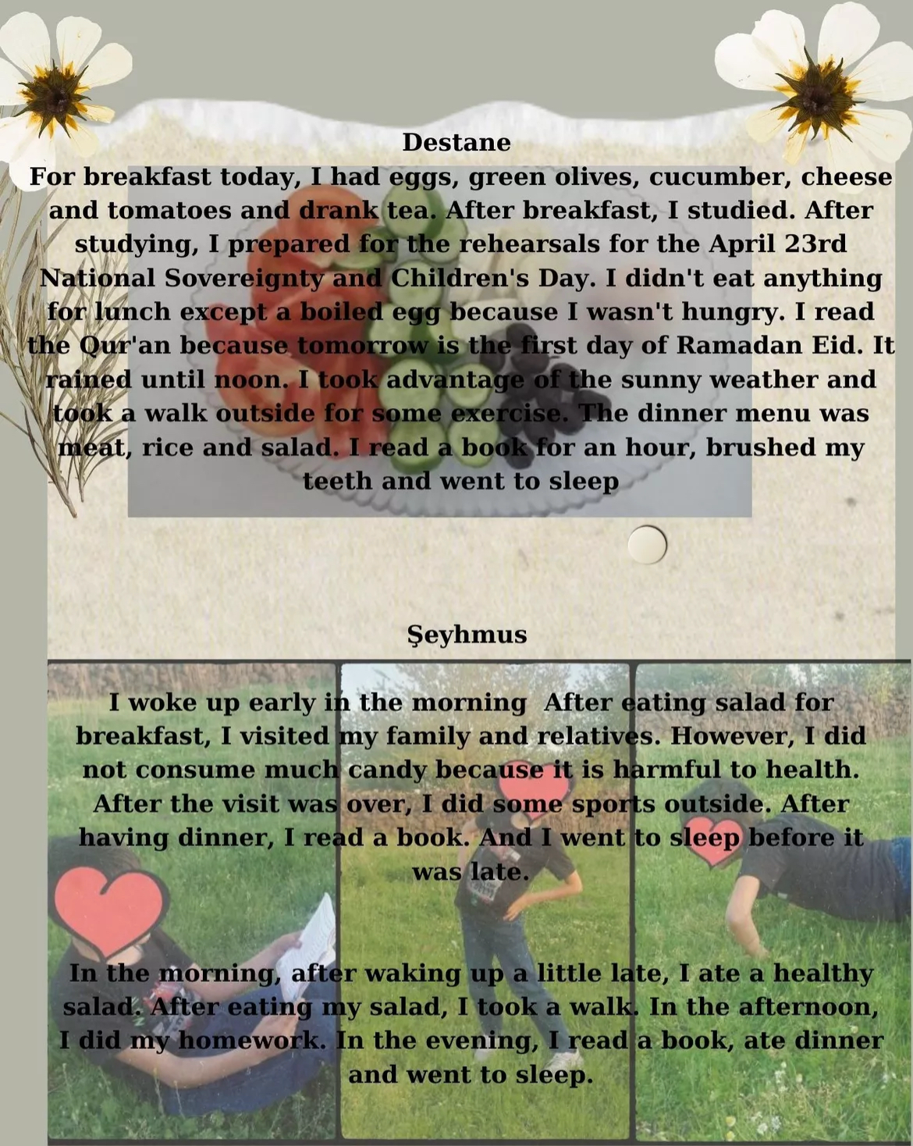
Students kept a diary of what they did at home.

The students are analyzing calories of packaged foods or nutrition facts label of the products. They are bringing them at the class and presenting of them in front of the class. They are reading ingredients, serving sizes, calories of them. They can explain these nutrition facts label that helps them learn what healthier food to eat or consume

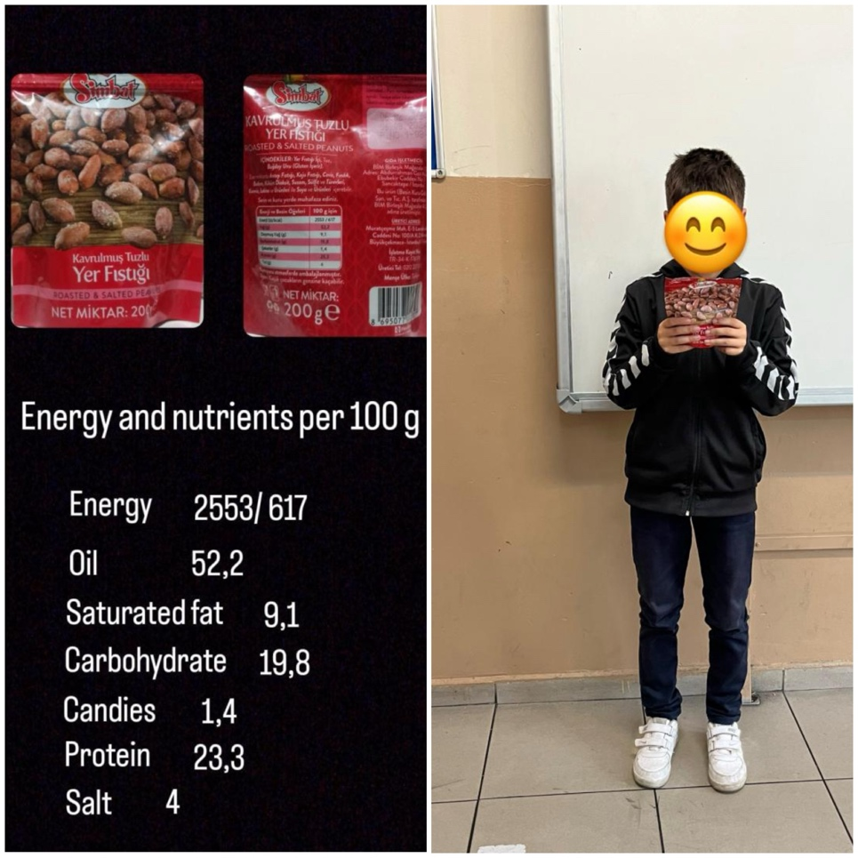

Students watched a video of type 1 diabetes and type 2 diabetes

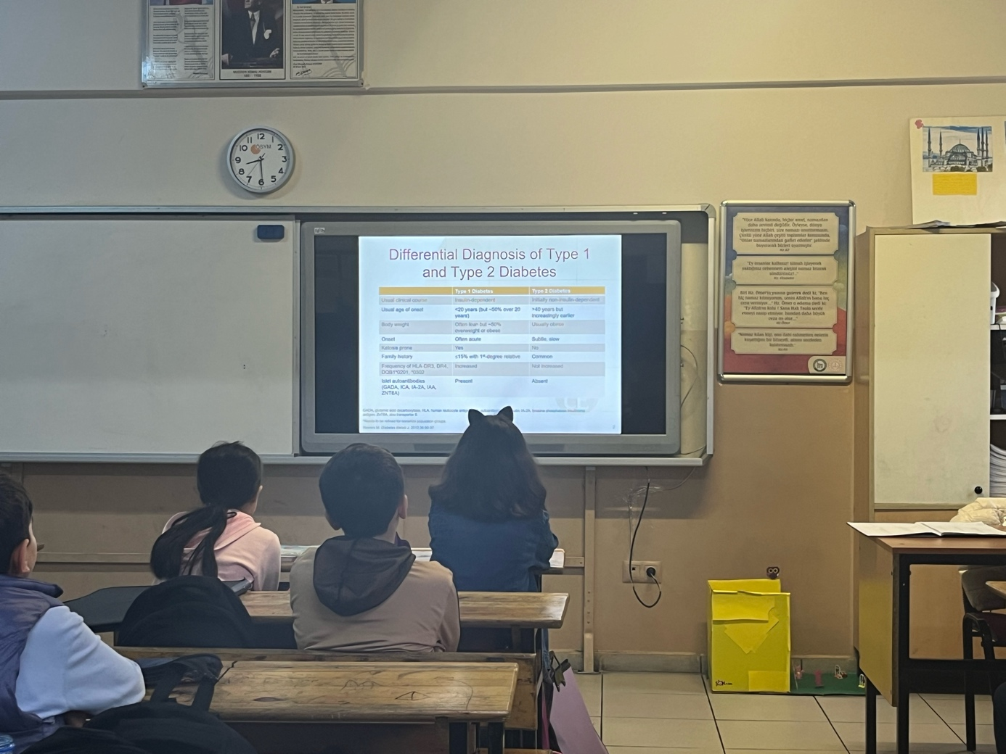

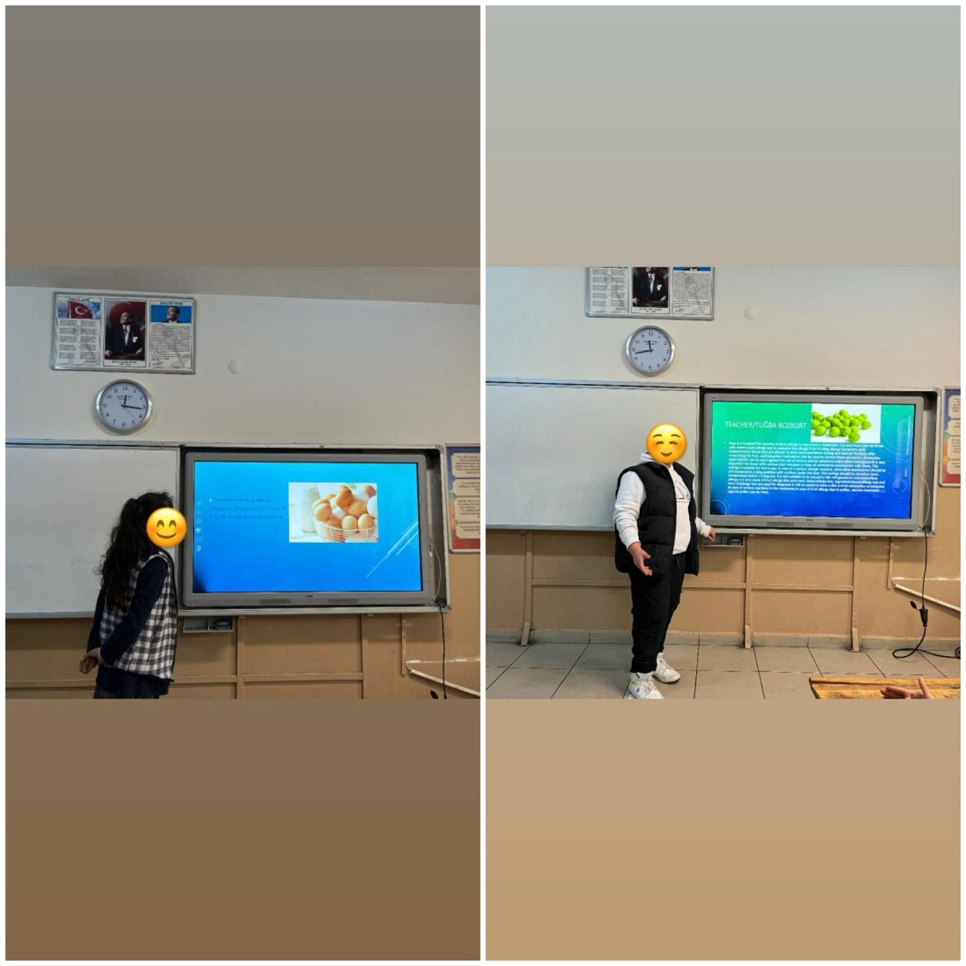
Students make a short presentation about which food they are allergic to. They should not eat and consume.

